Final Report

A three-dimensional (3D) interactive visualization system for wind environment assessment in cities

Project Supervisors
Internal – Dr Buddhika Karunarathne
External – Dr Asiri U. Weerasuriya

Group – WindVerse
K.M.S.N. Kulasekara | - 210302P
K.A.J.T. Kulathunga | - 210306G
H.N.A. Sandeepa | - 210571L

Table of Contents
1. Table of Contents 1
2. Introduction 2
3. Problem Statement 4
4. Research Objectives 5
5. Literature Review 6
5.1. Data Acquisition 7
5.1.1. Data Acquisition by Laser Scanners 7
5.1.2. Data Acquisition Using Depth Cameras 7
5.1.3. Data Acquisition Using physics-based simulations 8
5.2. Modelling Methods 8
5.2.1. Mass-Spring Systems 8
5.2.2. Finite Element Representation 9
5.2.3. Mesh Free Methods 9
5.3. Deformation Generation Approaches 9
5.3.1. Physics based approaches 10
5.3.2. Neural networks learning approaches 10
5.3.3. Hybrid approaches 11
6. Methodology 11
6.1. Wind Data Generation 12
6.2. Mesh Sequence Generation 13
6.2.1. Validating MuJoCo simulator 14
6.2.2. Generating the training dataset 14
6.3. Model Training 15
6.4. Developing Final Product 16
7. Results 17
7.1. Dataset Validation Results 18
7.2. Model Training Results 19
8. Progress 21
9. Conclusion 21
10. Bibliography 22

Introduction
Wind environment assessment has become a mandatory requirement for large-scale urban development and redevelopment projects in many countries, reflecting the critical importance of understanding how wind patterns influence pedestrian comfort, building safety, environmental quality, and overall urban liveability. Rapid urbanisation and the increasing prevalence of high-rise developments have significantly altered natural airflow patterns within cities, creating complex wind environments that can affect both the built environment and the people who occupy it. As urban areas become denser, the interaction between buildings and atmospheric flows can result in various aerodynamic phenomena, including wind acceleration, turbulence, downdrafts, and stagnant air zones. These effects can directly impact outdoor thermal comfort, air quality, and the safety of pedestrians. Consequently, urban planners, architects, and policymakers increasingly recognise the need to evaluate wind conditions during the planning and design stages of development projects.
Many governments and planning authorities have therefore incorporated wind environment assessments into their regulatory frameworks. For example, Hong Kong introduced the Air Ventilation Assessment (AVA) system in 2006 to ensure that major developments adequately consider wind conditions and preserve urban ventilation within its densely populated urban landscape [1]. Similar assessment practices have also been adopted in other regions where dense urban development and climatic conditions make airflow management a significant concern. Such policies highlight the growing recognition that wind is not merely an environmental factor but a critical component of sustainable urban design.
Wind environment assessments offer numerous benefits to both urban communities and city administrators. Effective urban ventilation contributes to the reduction of heat accumulation within cities, thereby mitigating the urban heat island effect and improving outdoor thermal comfort. Enhanced airflow also promotes better air quality by facilitating the dispersion of pollutants, reducing the concentration of harmful airborne particles and improving public health outcomes [2]. Furthermore, well-designed urban ventilation corridors can support natural cooling and ventilation in buildings, reducing reliance on energy-intensive mechanical cooling systems and lowering overall energy consumption. In addition to these environmental and economic benefits, wind assessments help identify potentially hazardous conditions such as excessive wind speeds around building entrances, public plazas, and pedestrian walkways, enabling designers to implement appropriate mitigation measures before construction begins.
To achieve these objectives, wind environment assessments traditionally rely on computational fluid dynamics (CFD) simulations and wind tunnel experiments. These techniques generate highly detailed information regarding airflow patterns, wind velocity, pressure distribution, and turbulence intensity at fine spatial and temporal resolutions [3]. CFD simulations allow researchers and engineers to model complex interactions between atmospheric flows and urban structures under varying environmental conditions, while wind tunnel testing provides valuable experimental validation of simulation results. Together, these methods provide comprehensive datasets that support informed decision-making throughout the urban planning process.
Despite their effectiveness, these assessment methods often produce vast quantities of highly technical data that can be challenging for non-specialists to interpret. A significant gap therefore exists between the complexity of wind simulation outputs and the ability of key stakeholders, including members of the public, urban planners, architects, developers, and municipal administrators to understand their practical implications [4]. Wind speed contour maps, vector fields, streamlines, turbulence visualisations, and numerical datasets often require specialised expertise to analyse correctly. As a result, important information regarding pedestrian comfort, safety risks, and environmental performance may not be easily accessible to many of the individuals involved in urban development decision-making processes.
Recent advances in three-dimensional wind visualisation have begun to address some of these challenges by providing more immersive and interactive methods for representing airflow data. The development of modern graphics technologies, virtual reality (VR), augmented reality (AR), and interactive simulation environments has created new opportunities for communicating complex environmental information to both experts and non-experts. These technologies can transform abstract numerical datasets into visual experiences that allow users to explore and better understand wind behaviour within urban environments. As a result, researchers have increasingly investigated the use of advanced visualisation techniques to improve the accessibility and interpretability of wind simulation results.
However, despite these technological advancements, many existing wind visualisation approaches remain difficult for non-experts to understand. Most systems continue to rely on traditional scientific visualisation techniques such as streamlines, particle traces, velocity vectors, and coloured contour maps. While these representations are valuable for engineers and researchers, they often require prior knowledge of fluid dynamics concepts to be interpreted correctly. For example, Vincent et al. [5] developed a virtual reality system that visualises airflow using streamlines. Although effective for representing airflow characteristics, such visualisations can be difficult for non-specialist users to relate to real-world wind experiences, limiting their usefulness as communication tools for broader stakeholder groups. Similar challenges are observed in many existing visualisation platforms where the emphasis remains on technical accuracy rather than intuitive understanding.
This research seeks to address this gap by developing a three-dimensional interactive wind visualisation system that transforms complex wind environment data into intuitive, real-world representations that can be readily understood by users regardless of their technical background. Rather than relying solely on abstract scientific visualisation methods, the proposed system will represent wind effects through familiar environmental objects and phenomena that people naturally associate with wind behaviour. By leveraging these familiar visual cues, the system aims to bridge the gap between complex simulation data and human perception, allowing users to intuitively assess wind strength, direction, and variability.
Furthermore, the interactive nature of the system will enable users to explore wind conditions from different viewpoints and locations within a virtual urban environment, providing a more engaging and realistic understanding of how wind affects specific areas. This approach has the potential to improve communication between technical experts and non-technical stakeholders, facilitate more informed decision-making during urban planning processes, and enhance public participation in development projects. Ultimately, by making wind behaviour more accessible and comprehensible, this research aims to contribute to safer, healthier, and more sustainable urban environments while demonstrating the value of intuitive visualisation techniques in environmental assessment and communication.
This approach represents a significant advancement over existing wind visualisation tools by combining the computational efficiency of machine learning with the physical constraints required to produce realistic wind-responsive object behaviour. Unlike traditional methods that often rely on abstract representations such as streamlines, vector fields, and contour maps, the proposed system visualises wind effects through familiar real-world objects. This allows users to intuitively understand wind conditions without requiring specialised knowledge of fluid dynamics or environmental engineering.
A key feature of the system is its interactive nature. Users can select an object from a predefined library, such as a flag, and place it at any location within the simulated wind field. The system then predicts and visualises the object's deformation in response to the local wind conditions. By providing immediate visual feedback, the platform enables users to explore wind behaviour at specific locations and gain a better understanding of how wind may affect different areas of a proposed urban development.
This capability offers significant benefits for urban planning and environmental assessment. Stakeholders can investigate wind conditions around pedestrian walkways, building entrances, public spaces, and other areas of interest without relying solely on technical reports. The interactive visualisation encourages exploratory analysis and allows users to compare different locations and scenarios, making it easier to identify potential comfort or safety concerns. Furthermore, the intuitive presentation of wind effects can facilitate communication and collaboration among planners, developers, government authorities, and members of the public.
The proposed research contributes to the growing field of environmental data visualisation by addressing the communication challenges associated with urban wind assessments. By transforming numerical wind data into observable physical phenomena, the system bridges the gap between complex simulation outputs and stakeholder understanding. This approach represents a shift from traditional static reporting methods towards more accessible, engaging, and actionable visualisation tools that support better-informed urban development decisions and promote safer, more sustainable urban environments.

Problem Statement

Despite the widespread use of sophisticated CFD software, a significant gap exists in how complex wind data are communicated to non-expert audiences. Tools such as OpenFOAM generate vast amounts of information describing wind velocity, pressure distribution, turbulence intensity, and airflow patterns across urban environments. These datasets provide valuable insights into wind behaviour and are essential for evaluating factors such as pedestrian comfort, natural ventilation, pollutant dispersion, and structural safety. However, the resulting information is typically presented through abstract visualisations such as vector fields, streamlines, particle traces, and colour-coded contour maps. While these representations are highly effective for engineers and CFD specialists, they often require specialised technical knowledge to interpret correctly. Consequently, urban planners, architects, developers, policymakers, and members of the public may struggle to understand how the simulated wind conditions translate into real-world effects. This communication barrier limits the accessibility of wind assessment results and can hinder informed decision-making regarding urban design, public safety, and environmental performance [6].
Although traditional physics-based simulation techniques can accurately model the physical effects of wind with a high degree of accuracy, they are computationally intensive and generally unsuitable for real-time interaction. Detailed CFD simulations often require substantial processing power and can take minutes or even hours to complete, depending on the complexity of the environment being analysed. This makes it difficult to provide immediate feedback during planning meetings, design reviews, or stakeholder consultations. As a result, users are often limited to examining precomputed simulation outputs, reducing opportunities for interactive exploration and scenario testing. This limitation presents a significant challenge for collaborative design processes, where rapid evaluation of multiple design alternatives is often required.
Our project seeks to address this two-fold problem by transforming abstract CFD outputs into a physically intuitive and interactive visual experience. Drawing inspiration from the Beaufort Wind Scale, which characterises wind strength based on its observable effects on objects and the surrounding environment [7], the system will represent wind conditions through the dynamic deformation of familiar virtual objects such as flags. Instead of requiring users to interpret technical flow visualisations, the system will allow them to observe realistic object movements that naturally convey information about wind speed, direction, and intensity. By leveraging familiar visual cues, the platform aims to make complex wind behaviour easier to understand for users regardless of their technical background.
The central problem addressed by this research is enabling users to place a selected object at any location within a simulated urban environment and instantly observe its localised deformation in response to the prevailing wind conditions. This functionality provides a powerful and intuitive method for assessing wind behaviour at specific points of interest. Users will be able to explore different locations within the environment, compare wind conditions across multiple areas, and gain immediate visual feedback without requiring additional simulations. By bridging the gap between complex engineering data and practical human understanding, the proposed system has the potential to improve stakeholder communication, support evidence-based urban planning decisions, and enhance the overall effectiveness of wind environment assessments. Ultimately, it represents a step towards more accessible, interactive, and human-centred approaches to environmental data visualisation.

Research Objectives
The primary objective of this research is to develop an efficient framework for predicting realistic three-dimensional (3D) object deformations, such as flags, under varying wind conditions. This work is motivated by the need for real-time, interactive wind-aware visualisation tools in areas such as urban planning and environmental assessment. While traditional physics-based simulation methods can produce highly accurate results, they are computationally expensive and unsuitable for real-time applications or interactive systems.
To address this limitation, the proposed approach decouples the heavy physics simulation from the real-time prediction process by leveraging precomputed simulation data and machine learning models. This allows the system to maintain physical realism while significantly improving computational efficiency, enabling fast and interactive visualisation of wind-induced object deformations.

- Physics-Based Deformation Data Generation
  - Integrate wind fields with a physics-based simulation environment to generate realistic and physically consistent object deformation sequences that accurately capture how flexible objects respond over time to varying wind speed, direction, and turbulence conditions.
  - Export the resulting deformed meshes in a standard format such as OBJ, including detailed vertex displacement and velocity data to preserve both the geometric changes and motion dynamics required for accurate reconstruction and machine learning-based analysis.
- Dataset Construction
  - Create a structured dataset that pairs initial object geometries and corresponding surrounding wind field conditions with their resulting deformed meshes, ensuring that each sample accurately represents the relationship between environmental wind inputs and the resulting physical deformation behaviour over time.
- Neural Model Development
  - Investigate and compare the performance of Physics-Informed Neural Networks (PINNs), Recurrent Neural Networks (RNNs), and other suitable neural network architectures in predicting mesh deformation under varying wind conditions, evaluating their ability to capture both spatial structure and temporal dynamics of object responses.
  - Optimize model architectures and training strategies to achieve a balance between prediction accuracy and computational efficiency, focusing on improving generalisation, stability, and real-time inference performance for practical deployment.
- System Integration
  - Implement a standalone simulation tool that accepts a pre-defined object and wind field as input and generates a dynamic sequence of object deformations, accurately capturing the object’s realistic response to varying wind conditions over time, while enabling flexible usage across different simulation scenarios.
  - Ensure compatibility with existing simulation and rendering pipelines to support seamless integration into real-time systems, allowing the generated deformation outputs to be efficiently visualised, processed, and incorporated into broader computational graphics or urban simulation frameworks.
- Performance Evaluation
  - Evaluate the proposed models based on both prediction accuracy and computational efficiency, assessing how well the predicted mesh deformations match ground-truth physics-based simulation results while also measuring inference speed and suitability for real-time applications.
  - Benchmark the results against traditional physics-based simulation methods in terms of runtime performance and memory usage, in order to quantify the trade-offs between computational cost and physical accuracy.

Literature Review
Our literature review revealed that there is currently no single, end-to-end application that fully supports interactive visualization of object deformation under varying wind conditions in a unified framework. While individual components of this problem have been studied extensively, such as wind simulation, physical modelling of deformable objects, and visualization techniques, they are often developed in isolation and are not combined into a cohesive real-time system. To better understand the existing research landscape and identify relevant gaps, we structured our literature review into three distinct sections: Data Acquisition, Modelling Methods, and Deformation Generation Approaches. This structured approach allowed us to systematically examine the state-of-the-art techniques in each area, compare their strengths and limitations, and understand how they contribute to the overall problem. By analysing these components separately, we were able to clearly identify the missing integration between accurate physical modelling and efficient real-time visualisation, thereby laying the foundation for a novel framework that combines these elements into a unified and practical solution.

Data Acquisition
This section reviews data-generation strategies for an interactive 3D wind-environment visualization system, focusing on three primary approaches: data acquisition using laser scanners, data acquisition using depth cameras, and physics-based simulation methods. Each approach offers distinct advantages and limitations in terms of accuracy, scalability, and suitability for capturing complex urban wind-related phenomena. Laser scanning techniques enable high-precision reconstruction of real-world urban geometries, while depth cameras provide flexible and cost-effective real-time spatial data capture in controlled environments. In contrast, physics-based approaches rely on computational models to simulate wind flow and object interactions, allowing for controlled generation of deformation data under varying environmental conditions. Together, these methods form the foundation for building comprehensive datasets required for training and validating interactive wind visualisation systems.

Data Acquisition by Laser Scanners
Laser scanning is a widely used data acquisition technique for generating highly accurate digital representations of real-world objects and environments. It works by precisely measuring distances to millions of surface points, producing dense point clouds that capture detailed geometric information. These point clouds can then be processed to create accurate 3D models for applications such as architectural documentation, urban modelling, and industrial design.
Cheng et al. [8] present a building modelling approach based on laser-scanning technology, where structures are scanned from multiple stations to fully capture their geometry and interior features. The individual scans are later registered using specialized software, and a complete 3D mesh is generated from the merged point cloud
Laser scanning offers several advantages, most notably its high accuracy and ability to capture complex and irregular shapes with detail. However, it also has significant limitations for this project. The technology is expensive, involves complex data processing, and is primarily designed for capturing static scenes. Since our work focuses on modelling dynamic deformation over time such as the motion of a tree in wind laser scanning cannot provide sequential deformation data. As a result, it is not suitable for generating the time-series data required to train our machine learning model.

Data Acquisition Using Depth Cameras
Depth cameras, such as the Kinect series, provide a low-cost and accessible alternative to laser scanners for 3D data acquisition, capturing both geometric and colour information. Ruchay et al. [9] present a multi-Kinect approach where each device simultaneously records depth point clouds and RGB images, which are then registered across cameras to reconstruct a complete 3D model.
The main advantages of depth cameras are their affordability, ease of setup, and ability to capture depth and colour data at high frame rates, making them suitable for recording dynamic motion. However, their lower accuracy, sensitivity to noise and lighting conditions, and limited range make them impractical for capturing large-scale tree deformation, where complex occlusions would result in incomplete and misaligned data.

Data Acquisition Using physics-based simulations
A controlled and systematic method for data acquisition can be achieved through physics-based simulation. Instead of relying on the logistical challenges of real-world measurements, simulations generate the required information in a virtual environment. High-fidelity computational fluid dynamics (CFD) tools provide detailed wind velocity fields. These fields can then drive the deformation of digital 3D object models in platforms that apply mass-spring or finite element methods (FEM) to compute time-series deformations. In their approach, Du et al. [10] have followed this method, using a co-simulation framework that utilizes a CFD model to generate the necessary data. However, they also mention that their framework is equally applicable to experimental data.
This approach produces large-scale, dynamic deformation datasets with precise ground-truth values for every vertex’s position and velocity, which are far more consistent than real-world data, which is prone to sensor noise, occlusion, and environmental variability. Such clean, high-resolution data are essential for building robust models that capture the complex relationships between wind parameters and object deformation.

Modelling Methods
The literature is rich with various approaches for modelling deformable objects. These methods include a network of point masses connected by springs (mass-spring models), the subdivision of an object into interconnected elements (finite element representation), and methods that do not rely on a fixed mesh (mesh-free deformation). A detailed explanation of each is presented below.

Mass-Spring Systems
Mass-spring models are a simple and widely used approach for simulating the deformation of flexible 3D objects. In this method, an object is represented as a network of point masses connected by springs that define its elastic behaviour. Due to their simplicity and computational efficiency, mass-spring systems are commonly used for real-time shape modelling and animation [11,12].
Zaidi et al. [13] applied a mass-spring model to simulate the interaction between deformable objects and a multi-fingered robotic hand, where nonlinear behaviour emerged from large deformations despite linear spring assumptions.
Although mass-spring models are efficient and easy to implement, they are less physically accurate than methods such as the Finite Element Method (FEM). Their performance is also highly sensitive to parameter selection, including spring stiffness, mass distribution, and mesh topology, making model tuning a challenging and time-consuming process [12,14].

Finite Element Representation
The Finite Element Method (FEM) is a highly accurate technique for simulating object deformation by subdividing a structure into a mesh of interconnected elements and computing stress, strain, and displacement across the model. Due to its strong physical foundations, FEM is widely used in applications such as surgical simulation, animation, and mechanical engineering [15].
Petit et al. [16] proposed a method for tracking 3D elastic objects using RGB-D data by mapping point clouds to a tetrahedral FEM model. Their approach uses ICP to estimate rigid transformations, computes elastic forces from point-to-mesh correspondences, and numerically solves the resulting mechanical equations to simulate deformation.
Compared to mass-spring models, FEM provides greater physical accuracy and handles complex geometries more effectively [17,18]. However, its high computational cost often limits its use in real-time applications without extensive optimization [19].

Mesh Free Methods
Mesh-free methods model dynamic systems using a set of scattered points without relying on a predefined mesh or fixed node connectivity. Due to their flexibility, these techniques are widely used in engineering, electromagnetics, and computer graphics [20]. The object is represented by points distributed over its surface and interior, which satisfy equilibrium equations without requiring explicit neighbourhood relationships [21].
While mesh-free methods can handle complex deformations, they often suffer from numerical instability, particularly when applying boundary conditions, which limits their robustness in practice [22].

Deformation Generation Approaches
There are several approaches to generating realistic deformations of 3D objects under external forces such as wind, each offering a different balance between physical accuracy and computational efficiency. These methods can broadly be categorized into physics-based approaches, neural networks learning approaches, and hybrid of those two.

Physics based approaches
Physics-based methods rely on solving governing physical equations, such as the Navier–Stokes equations for fluids and elasticity equations for structural deformations. To realistically capture cloth motion under airflow, aerodynamic force models and physics-based cloth animation techniques have been developed [23]. Although these approaches provide high-fidelity results, they are computationally expensive, making them unsuitable for real-time applications [24]. More advanced solvers, such as SOFA and ARCSim physics engines offer high accuracy but still face scalability limitations when simulating complex environments over extended time sequences [25].
In particular, ARCSim builds on the adaptive anisotropic remeshing approach proposed by Narain et al., enabling accurate simulation of cloth by dynamically refining the mesh in regions of high deformation. While this allows realistic modeling of folds and wrinkles, the associated remeshing and solver complexity result in high computational cost, limiting its suitability for real-time applications [26].

Neural networks learning approaches

Neural networks learning approaches attempt to replace the numerical solvers by directly learning mappings from input conditions (such as wind velocity fields) to object deformations. For instance, graph neural networks (GNNs) have been applied to learn mesh-based physical interactions while preserving topological relationships between nodes [27]. Similarly, recurrent neural networks (RNNs) have been utilized to model temporal sequences of deformations [28]. These methods provide real-time inference once trained but may struggle to generalize outside their training distribution and often require large datasets generated by physics simulators. In contrast, the approach by Tawbe et al [29] combines sampling methods to simplify the point representation of the object, and they use neural gas fitting and feedforward neural network to learn a compact representation of the deformation without requiring knowledge of the material properties. This allows them to achieve low computational complexity and reliable results. Their method first represents the 3D surface using neural gas and then trains a network to predict the positions of these simplified nodes, allowing it to generalize to larger forces not seen in the training data.
More recently, physics-encoded Graph Neural Networks have been proposed to enhance deformation prediction by explicitly incorporating physical constraints into the graph message-passing process. By representing rigid and deformable objects as interacting graph nodes, these models can accurately capture contact-induced deformations while preserving mesh topology. This integration of learned representations with physical priors improves generalization and stability compared to purely data-driven neural approaches, particularly in complex contact scenarios. [30]

Hybrid approaches
Hybrid methods such as Physics-Informed Neural Networks (PINNs) combine the strengths of physics-based methods and purely data-driven approaches by embedding physical laws (e.g., partial differential equations) into the loss function during training [31]. This allows PINNs to respect physical constraints while reducing the reliance on large, labelled datasets. Recent studies have shown that PINNs can effectively model deformation dynamics by enforcing conservation laws directly within the neural architecture [32], thus bridging the gap between fidelity and efficiency. However, PINNs can be challenging to train for highly complex geometries or turbulent flow fields [33].

A vital consideration across all these approaches is the strategy used for handling mesh deformation. The cost of generating a new mesh entirely can be overwhelming [34. Instead of regenerating meshes at every timestep, many methods update node displacements directly. This has several advantages: (i) Preserving mesh topology ensures that vertex connectivity remains intact, which is critical for stability in fluid-structure interaction simulations [35]; (ii) Computational efficiency is improved since updating vertex positions is significantly cheaper than regenerating complete meshes [36]; (iii) Enhanced realism in rendering can be achieved using displacement mapping techniques, which enrich surface details with complexity out increasing mesh [37]; and (iv) Numerical stability is improved in large-deformation finite element simulations, as consistent mesh topology reduces errors caused by mesh distortion [38]. Together, these advantages make node displacement–based deformation a practical choice for both physics-driven and learning-driven frameworks, particularly in real-time or resource-constrained applications.
In summary, physics-based methods remain the most accurate but computationally demanding, fully NN-based methods offer fast approximations but may lack robustness, while PINNs present a promising hybrid solution that integrates physical constraints with learning-based generalization. The decision of which approach to use often depends not only on the balance between accuracy and efficiency but also on whether node displacement can be leveraged to preserve topology, improve stability, and reduce computational overhead.

Methodology
In this part, we discuss about the high-level description of our current ongoing path for this project. This is consisted of four main parts as data generation for training, model training, evaluation of model and develop the final product with results. Each phase plays a critical role in ensuring that the proposed system can effectively capture the physics-driven deformation of objects under wind influence while also providing a computationally efficient, learning-based simulation framework. A high-level overview of this methodology is shown below, and the subsequent subsections provide a detailed description of each stage.
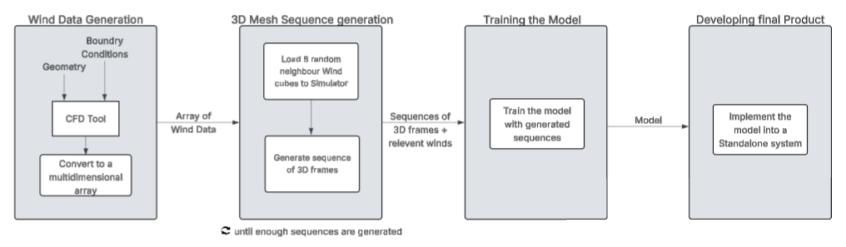
Figure ‎5-1: High - Level Flow Diagram of Development

Wind Data Generation
To ensure robust generalization of the model, CFD outputs will be generated for a broad and diverse set of geometries, rather than being confined to a single canonical case. This approach allows the model to encounter a variety of flow patterns, turbulence structures, and boundary interactions, thereby improving its ability to predict wind effects across different scenarios. We currently using an open-source wind simulator called Openfoam.
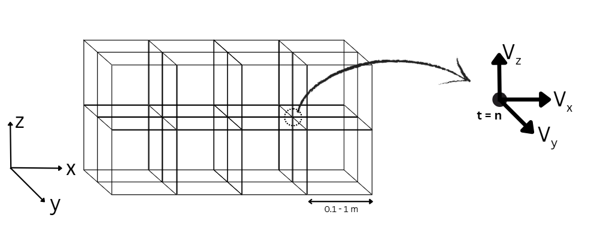
Figure ‎5-2: Wind data representation as a grid
The simulations will be conducted with high temporal resolution, capturing wind data every 0.1 seconds. This frequency is critical for resolving transient wind behaviour and the rapid velocity fluctuations inherent in real-world conditions. Spatial resolution will be maintained at 1 meter, striking a balance between sufficient flow field detail and manageable computational cost. This ensures that both large-scale flow structures and finer turbulent eddies are adequately resolved.
The raw outputs, consisting of three-dimensional velocity vectors, will be structured into 5D arrays. These arrays record the three velocity components (u, v, w) at each (x, y, z) grid point over successive time steps. This multidimensional representation preserves both spatial and temporal correlations, making it highly suitable for physics-based simulations and training data-driven models, such as neural networks. By generating such comprehensive, high-fidelity datasets, this workflow establishes a strong foundation for learning complex wind-induced behaviours and accurately predicting the dynamic response of flexible objects.

Mesh Sequence Generation
Dataset generation process is consisting of mainly two parts.
- MuJoCo simulator validation and parameter tuning with ARCSim simulator
- Generate the training dataset with MuJoCo simulator
We utilise the MuJoCo physics simulator to generate our training dataset. As MuJoCo implements wind as a global vector field, we incorporated the aerodynamic force calculation model from the ARCSim codebase to address this limitation. This allows us to explicitly calculate wind forces for each node and pass them directly to the MuJoCo solver. Consequently, it is essential to validate this hybrid approach.
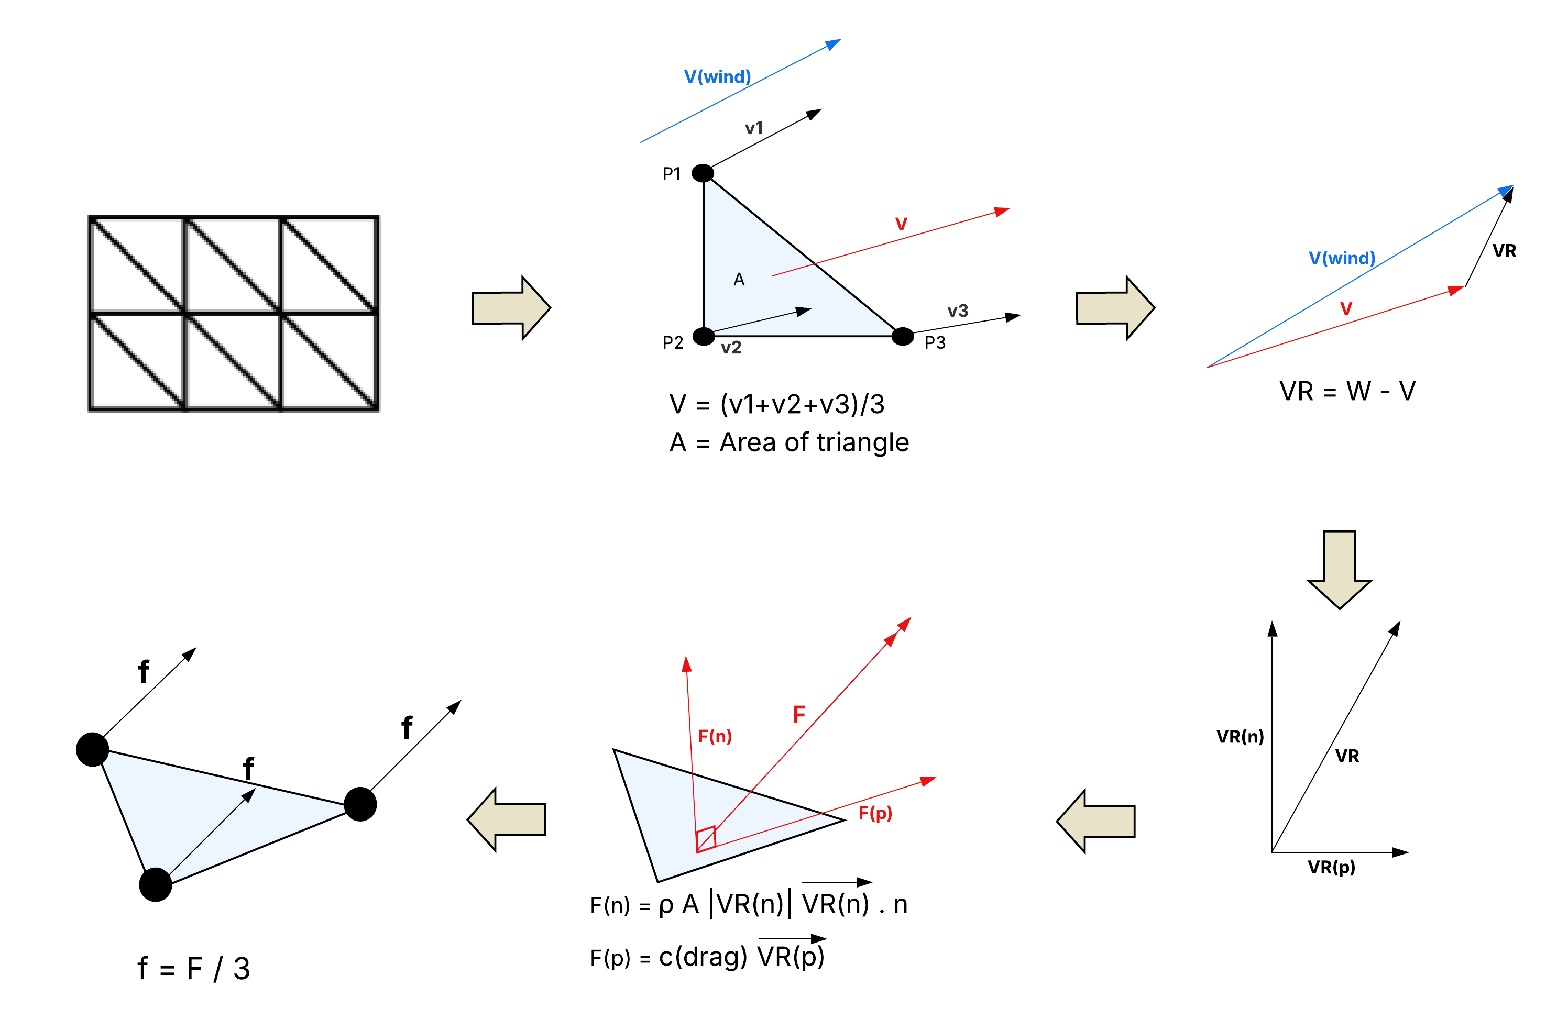
To this, we benchmark our simulation against ARCSim, a well-established framework for cloth deformation in wind fields [39]. Although ARCSim is proven to yield high-fidelity results, its accuracy relies heavily on adaptive remeshing. This process results in inconsistent node counts across frames, rendering the raw data unsuitable for training neural networks. Therefore, we employ MuJoCo as our primary simulator for dataset generation, while using ARCSim as the ground truth to fine-tune MuJoCo’s parameters.

Validating MuJoCo simulator
To validate this approach, we subject both simulators to an identical global wind field and generate corresponding flag deformation sequences. We then evaluate the fidelity of the MuJoCo simulation by computing the Uni-directed Chamfer distance, treating the ARCSim output as the reference source and the MuJoCo output as the target.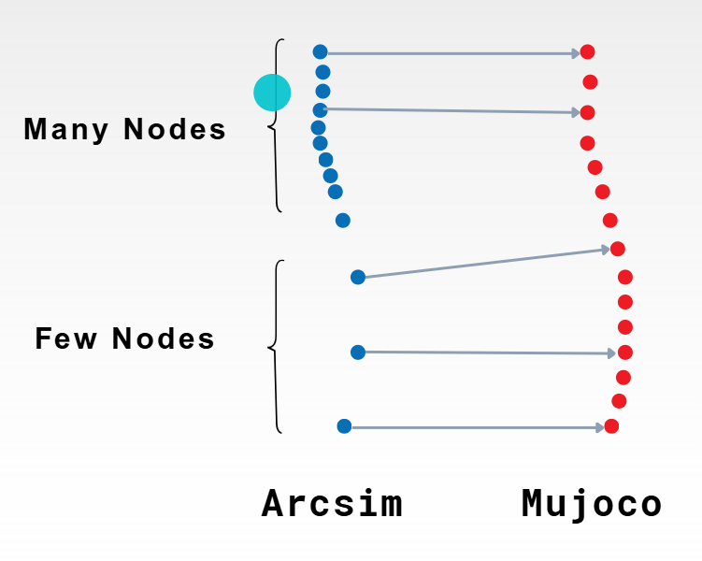 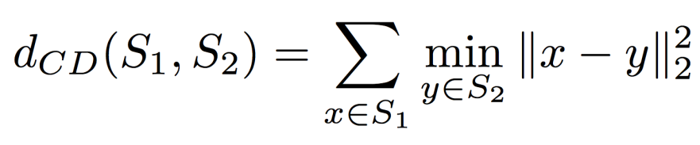
We employ a grid search strategy to calibrate the following MuJoCo simulation parameters: viscosity, node mass, damping, Poisson's ratio, thickness, Young's modulus, and solver reference (solref). Furthermore, we optimise the constants governing our custom aerodynamic force model, specifically air density and the drag coefficient.

Generating the training dataset
Mesh sequence generation is a pivotal step in preparing high-quality datasets for training predictive models of object deformation under dynamic wind conditions. The process commences by loading the initial 3D object into the centre of a high-fidelity, physics-based simulation environment. For our dataset generation, we utilise the previously parameter tuned MuJoCo simulator. We selected this simulator specifically for its ability to accurately model complex material behaviours including elasticity, bending, and stretching [40] and for its Python interface, which facilitates the customisation of wind data input patterns.
Once the object is positioned, a set of randomly selected neighbouring wind data cubes is assembled to form a comprehensive volumetric wind environment around the object, ensuring it is fully embedded within the wind field. This configuration allows the simulation to account for heterogeneous wind conditions, turbulence, and directional variations that the object might encounter in real-world scenarios. To further enhance generalisation, we apply data augmentations, such as scaling the wind magnitude by a random factor and rotating all wind vectors by a random angle.
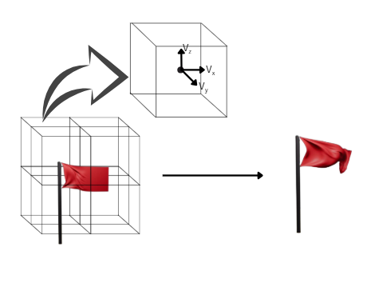
Figure ‎5-3: Generating object deformations

Within this wind environment, the simulator generates a sequence of 3D frames representing the object’s deformation over time. Each frame captures the new position and velocities of vertices under the influence of wind, preserving fine-scale spatial and temporal deformation patterns. After a complete sequence is generated for one wind configuration, a new random wind data point set is loaded, and the process is repeated with the same initial object, creating multiple sequences that encompass a wide variety of wind-object interactions. By iterating this procedure many times across different wind configurations, a large and diverse dataset of dynamic 3D meshes is created.
Each sequence captures both small-scale details, such as local bends and twists, and large-scale deformations caused by strong gusts or directional changes in the wind. By covering a wide range of scenarios, the dataset ensures that trained models generalise well to unseen objects and wind conditions. Additionally, the use of high-accuracy physics simulators guarantees that the generated sequences reflect realistic physical behaviour, making them highly suitable for applications that require precise predictions of wind-induced object dynamics, such as flags and other deformable structures. This systematic approach allows for the creation of training datasets for our next step.

Model Training
Model Training focuses on developing predictive models capable of accurately simulating the dynamic deformations of objects under varying wind conditions. Multiple neural network architectures will be explored to determine the most suitable approach, including Graph Neural Networks (GNNs), Physics-Informed Neural Networks (PINNs), and Recurrent Neural Networks (RNNs). GNNs are particularly effective for learning on 3D meshes, as they represent the mesh as a graph where nodes correspond to mesh vertices and edges represent connectivity, enabling the network to capture local and global spatial relationships. RNNs are designed to handle temporal sequences, making them suitable for modelling the evolution of deformations over time. PINNs incorporate physical constraints directly into the learning process, which improves generalisation and ensures that predicted deformations respect the underlying physical laws.
We are using node displacements or velocity differences both as predicting target. By predicting how each vertex moves relative to its previous position, the mesh connectivity remains fixed, preserving the topology of the object and ensuring consistency across frames. This approach simplifies the learning task and reduces errors that could arise from reconstructing complete meshes while also maintaining the structural integrity of the object. For non-sequential models, additional input features, including the instantaneous velocities of mesh nodes (u, v, w components), will be provided to improve accuracy. This allows the network to incorporate the current dynamic state of the object, enhancing predictive performance even without explicit temporal modelling.
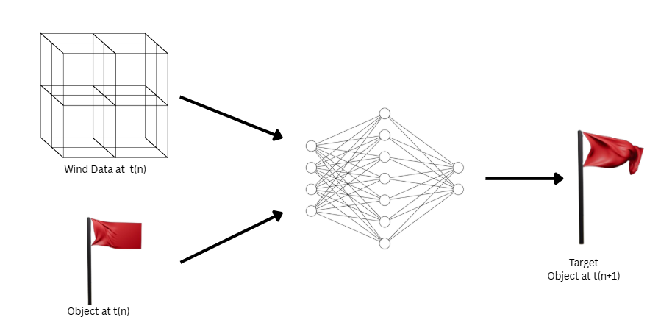
Figure ‎5-4: Model Training Process
The networks will be trained on sequences of 3D meshes and corresponding wind velocity fields. Loss functions will be designed to minimize vertex displacement errors while also penalising physically implausible deformations, such as excessive stretching or unrealistic acceleration. Hyperparameters, including learning rates, number of layers, hidden units, and graph connectivity for GNNs will be tuned to maximize performance. Model evaluation will use metrics that measure both spatial accuracy and temporal consistency, ensuring that predicted sequences closely match simulated behaviour. The best-performing architecture, selected through systematic experimentation, will provide a robust and generalizable model capable of accurately predicting the dynamic response of objects to complex, time-varying wind conditions, while maintaining the original mesh connectivity.

Used Model Architectures

Simple Neural Network [SNN]
As an initial baseline, we implemented a standard, few-layer feedforward neural network (SNN). This model was designed to take the flattened physical state of the flag combining node kinematics and environmental wind features and directly map them to predicted spatial accelerations. While this approach provided a computationally lightweight starting point to validate our data processing and training pipelines, it inherently lacked the relational capacity required for complex material physics. Because the SNN processes inputs as a single, disconnected one-dimensional vector, it is mathematically blind to the underlying mesh topology. Consequently, it cannot comprehend the structural connections between individual cloth particles, severely limiting its ability to accurately model the localized tension, shear forces, and highly non-linear wave dynamics characteristic of a flag in the wind.
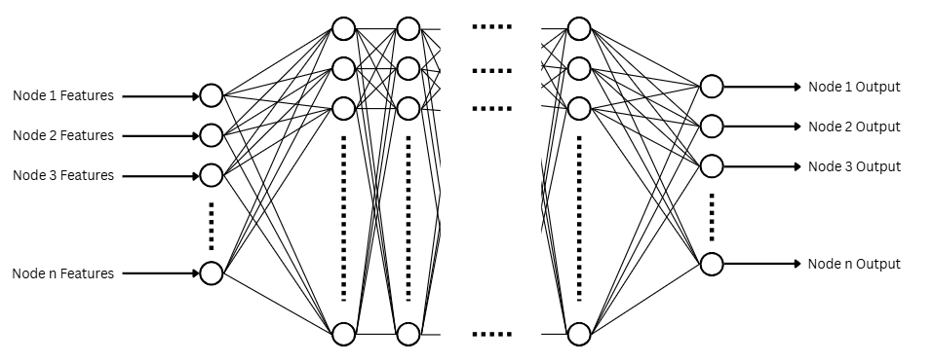
- Node Features – Position / Velocity / Acceleration in t-1 and wind for Node
- Node Output – Acceleration in t

Long Short Term Memory Blocks [LSTM]
To capture the sequential and temporal dynamics of the fabric, we experimented with models incorporating Long Short-Term Memory (LSTM) blocks. However, processing the entire high-dimensional 3D mesh directly through recurrent layers is computationally prohibitive and prone to memory bottlenecks. To resolve this and efficiently reduce dimensionality, we leveraged the spatial processing power of Convolutional Neural Networks (CNNs). By applying a CNN as an initial encoder, we were able to extract local structural features and compress the grid into a compact latent representation. This allowed the LSTM core to focus entirely on modelling the sequential physics such as momentum and wave propagation over time before a reverse CNN decoder reconstructed the final spatial accelerations.
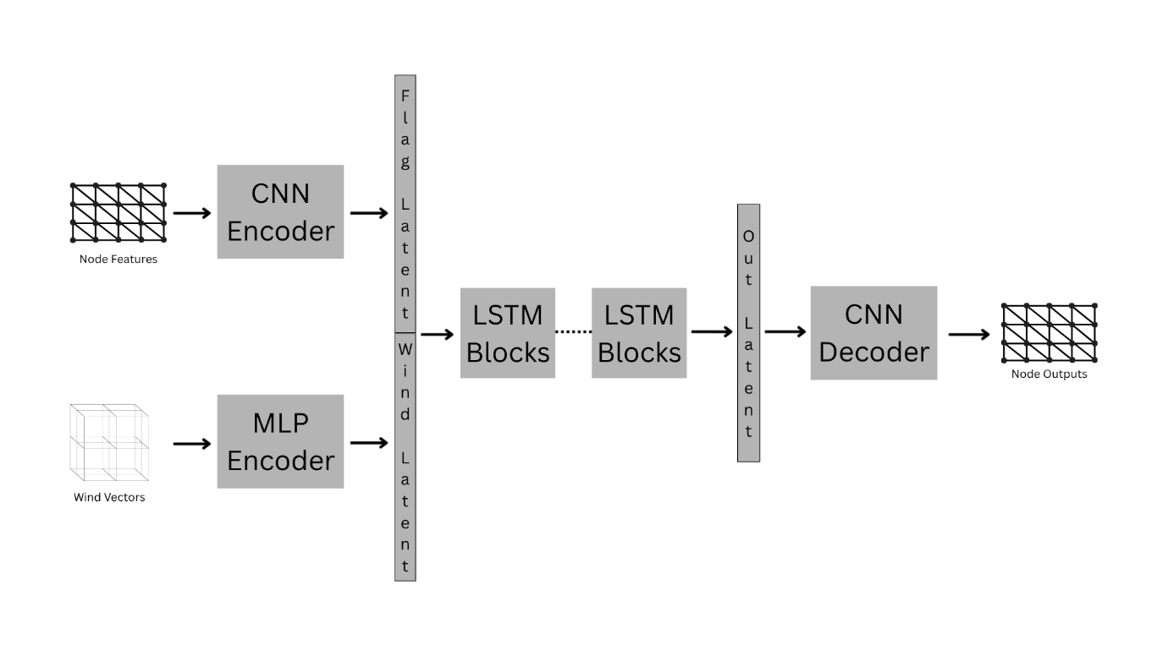

Graph Neural Network [GNN]
To overcome the structural blindness of grid-based and flattened architectures, we ultimately adopted a Graph Neural Network (GNN) framework, specifically utilizing a MeshGraphNet architecture. Unlike convolutional networks that assume a rigid and static spatial grid, the GNN natively models the fabric as a dynamic 3D mesh. In this formulation, nodes correspond to individual physical cloth particles, and edges explicitly define the structural constraints and physical threads connecting them. Through an iterative message-passing mechanism, the network computes localized physical forces such as edge tension, bending resistance, and aerodynamic drag by exchanging latent feature vectors across these established connections. This edge-aware architecture explicitly respects the chaotic, non-linear topology of folding cloth, enabling the model to successfully maintain structural integrity and accurately predict physical micro-dynamics during long autoregressive rollouts where previous architectures experienced catastrophic state collapse.
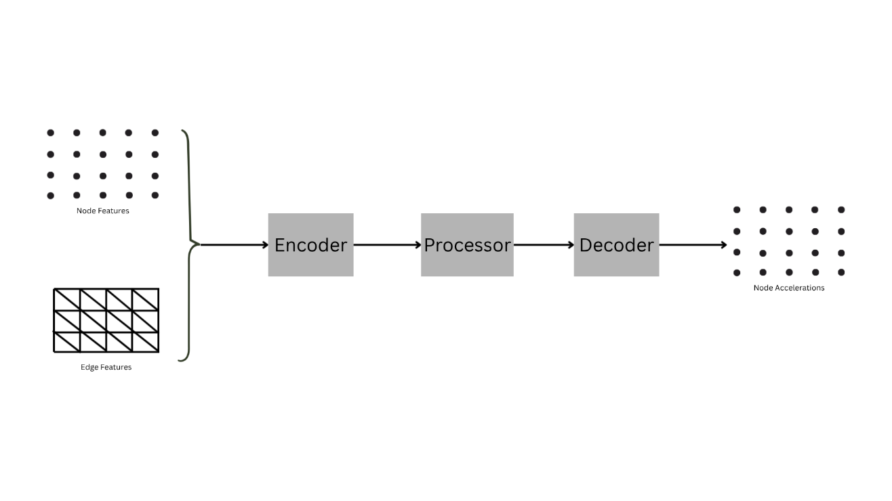
- Encoder
The Encoder serves as the critical entry point for the Graph Neural Network, responsible for transforming raw physical measurements into a unified, high-dimensional latent space. It utilizes two independent Multi-Layer Perceptrons (MLPs): the Node Encoder, which embeds the isolated physical and environmental state of each individual cloth particle, and the Edge Encoder, which models the dynamic structural springs connecting adjacent nodes. By projecting these raw physical properties into a defined hidden dimension, the Encoder translates standard Newtonian mechanics into a rich mathematical representation, preparing the data for the core message-passing network.
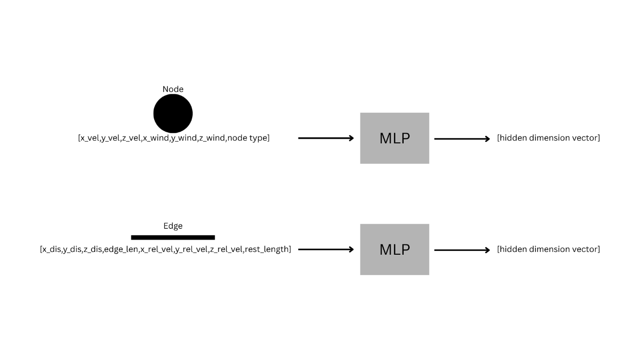
 | 3 * velocity | x, y, z velocity of node
Node Features | 3 * wind | x, y, z wind vector for node
 | node type | pinned / not pinned
 | 3 * displacement | x, y, z Edge vector component
Edge Features | edge length | Euclidean distance (L2 norm) between the two nodes
 | 3 * relative velocity | difference in velocity between the two nodes
 | rest length | original distance between these two nodes at t=0

- Processor
The Processor is the core computational engine of the Graph Neural Network. While the Encoder simply translates raw data into a latent space, the Processor simulates the physical laws of the fabric. It does this by executing a localized message-passing algorithm that mathematically mimics how forces travel through physical threads.
      - Edge Update
Before a node can move, the network must calculate the physical strain on the threads connected to it. The block concatenates the latent state of the sender node, the receiver node, and the edge connecting them. By passing this combined vector through the Edge MLP, the network calculates an updated edge feature. In physical terms, this step computes the localized interacting forces such as tension, shear, or collision occurring between any two connected particles.
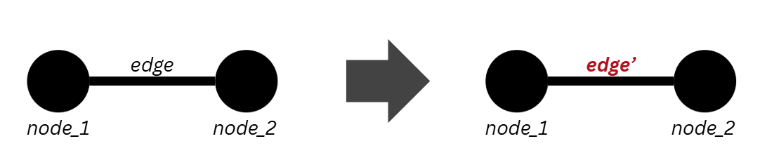

      - Node Update
Once the interactions are calculated along the edges, they must be applied to the particles. Using a sum aggregation scheme, each receiving node acts as a collection point, summing up all the incoming updated edges from its immediate neighbours. This perfectly mirrors Newtonian mechanics calculating the net force acting on a particle. The node then concatenates this net force with its own current state and passes it through the Node MLP to update its internal kinematic state.
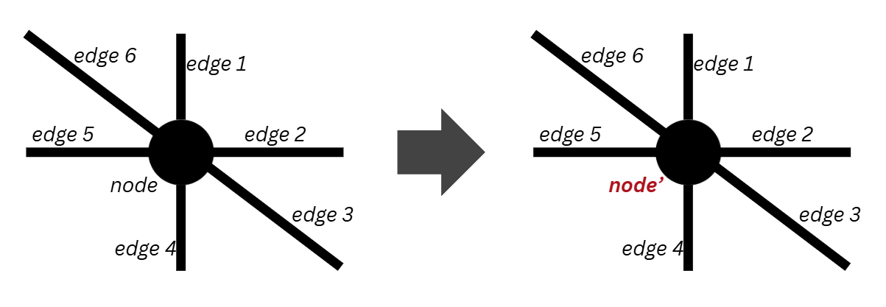

      - Residual Connections (Deep Wave Propagation)
At the end of the forward pass, the block adds the newly computed updates directly back to the original input vectors (x + updated_nodes). This residual connection is mathematically crucial. By passing the identity of the previous state forward, it prevents the vanishing gradient problem. This allows to stack many Processor blocks consecutively. Physically, stacking n blocks means a force applied at one end of the flag can propagate across n different edges in a single time step, allowing the network to simulate rapid, complex wave propagation across the entire fabric.
- Decoder
The Decoder serves as the final projection stage of the network, responsible for translating the abstract, high-dimensional latent representations back into interpretable, real-world physical quantities. After the fabric's state has been iteratively updated and propagated through the sequential Processor blocks, each particle is represented by a deeply contextualized h-dimensional latent vector. The Decoder utilizes a localized Multi-Layer Perceptron (MLP) to map these node-level latent vectors directly into a 3-dimensional output space, representing the predicted spatial accelerations ( a_x, a_y, a_z ) for each particle at the current time step. Crucially, unlike the internal Encoder and Processor MLPs, the Decoder specifically omits Layer Normalization. This is a deliberate architectural necessity because the final outputs are raw, unbounded kinematic values rather than bounded latent embeddings, removing normalization ensures the network retains the mathematical freedom to predict the full, unrestricted magnitude of physical forces required to drive the simulation forward.

Final Product
The final outcome of this project is the Wind Visualization System, an interactive three-dimensional desktop application that brings the wind-data pipeline of Section 6.1 and the trained deformation model of Section 6.3 together into a single, usable tool. Instead of presenting wind as static contour plots or raw numerical tables, the system allows a user to place familiar physical objects into a virtual environment, animates the surrounding wind field from real computational fluid dynamics (CFD) output, and deforms those objects in real time using our learned model. In this way it realises the interactive wind visualisation system set out in the Introduction, translating dense and highly technical CFD data into an intuitive, explorable scene. The application is launched from main.py, which first checks that the required dependencies are present and then starts a PyQt5 application whose main window, defined in ui/main_window.py, hosts the entire interface. To make the product easy to run on Windows, it is distributed with a self-contained portable Python runtime (the python/ folder, together with the run.bat and setup.bat helpers), so that it can be started by double-clicking, without any system-wide installation.
Architecture Overview. The system follows a layered, modular design in which each Python package has a single, well-defined responsibility and the higher layers depend only on the layers beneath them. The user-interface layer (ui/) contains the MainWindow that assembles the docked layout, toolbar, menus and status bar; the ObjectLibraryPanel that provides the drag-and-drop palette of placeable objects; and the SimulationController that drives the animation loop. The rendering layer (renderer/) holds the Scene, which owns the camera, the placed objects, the wind field and all display state; the Camera, which implements orbit, pan and zoom together with a smooth, eased focus animation; the OpenGLWidget, which performs the fixed-function OpenGL drawing, mouse picking and screen-to-world ray casting; and a small wind_colormap module that defines the Beaufort wind-speed colour bands. The geometry layer (objects/) provides the ObjectMesh class, which loads and manipulates triangular meshes from OBJ, STL or raw arrays, recomputes surface normals and exposes per-type constraints, alongside the bundled flag, cloth, tree and pole meshes. The data layer (wind_data/) provides the WindField, which stores the time-varying wind as a five-dimensional array and answers interpolated velocity queries, and the openfoam_loader, which parses raw OpenFOAM output into that representation. Finally, the model layer (models/) provides the DeformationModel inference wrapper, the MeshGraphNet network itself, the central config.py, and the bundled pretrained weights (best_model.pth) and mesh topology (topology_edge_index.npy).
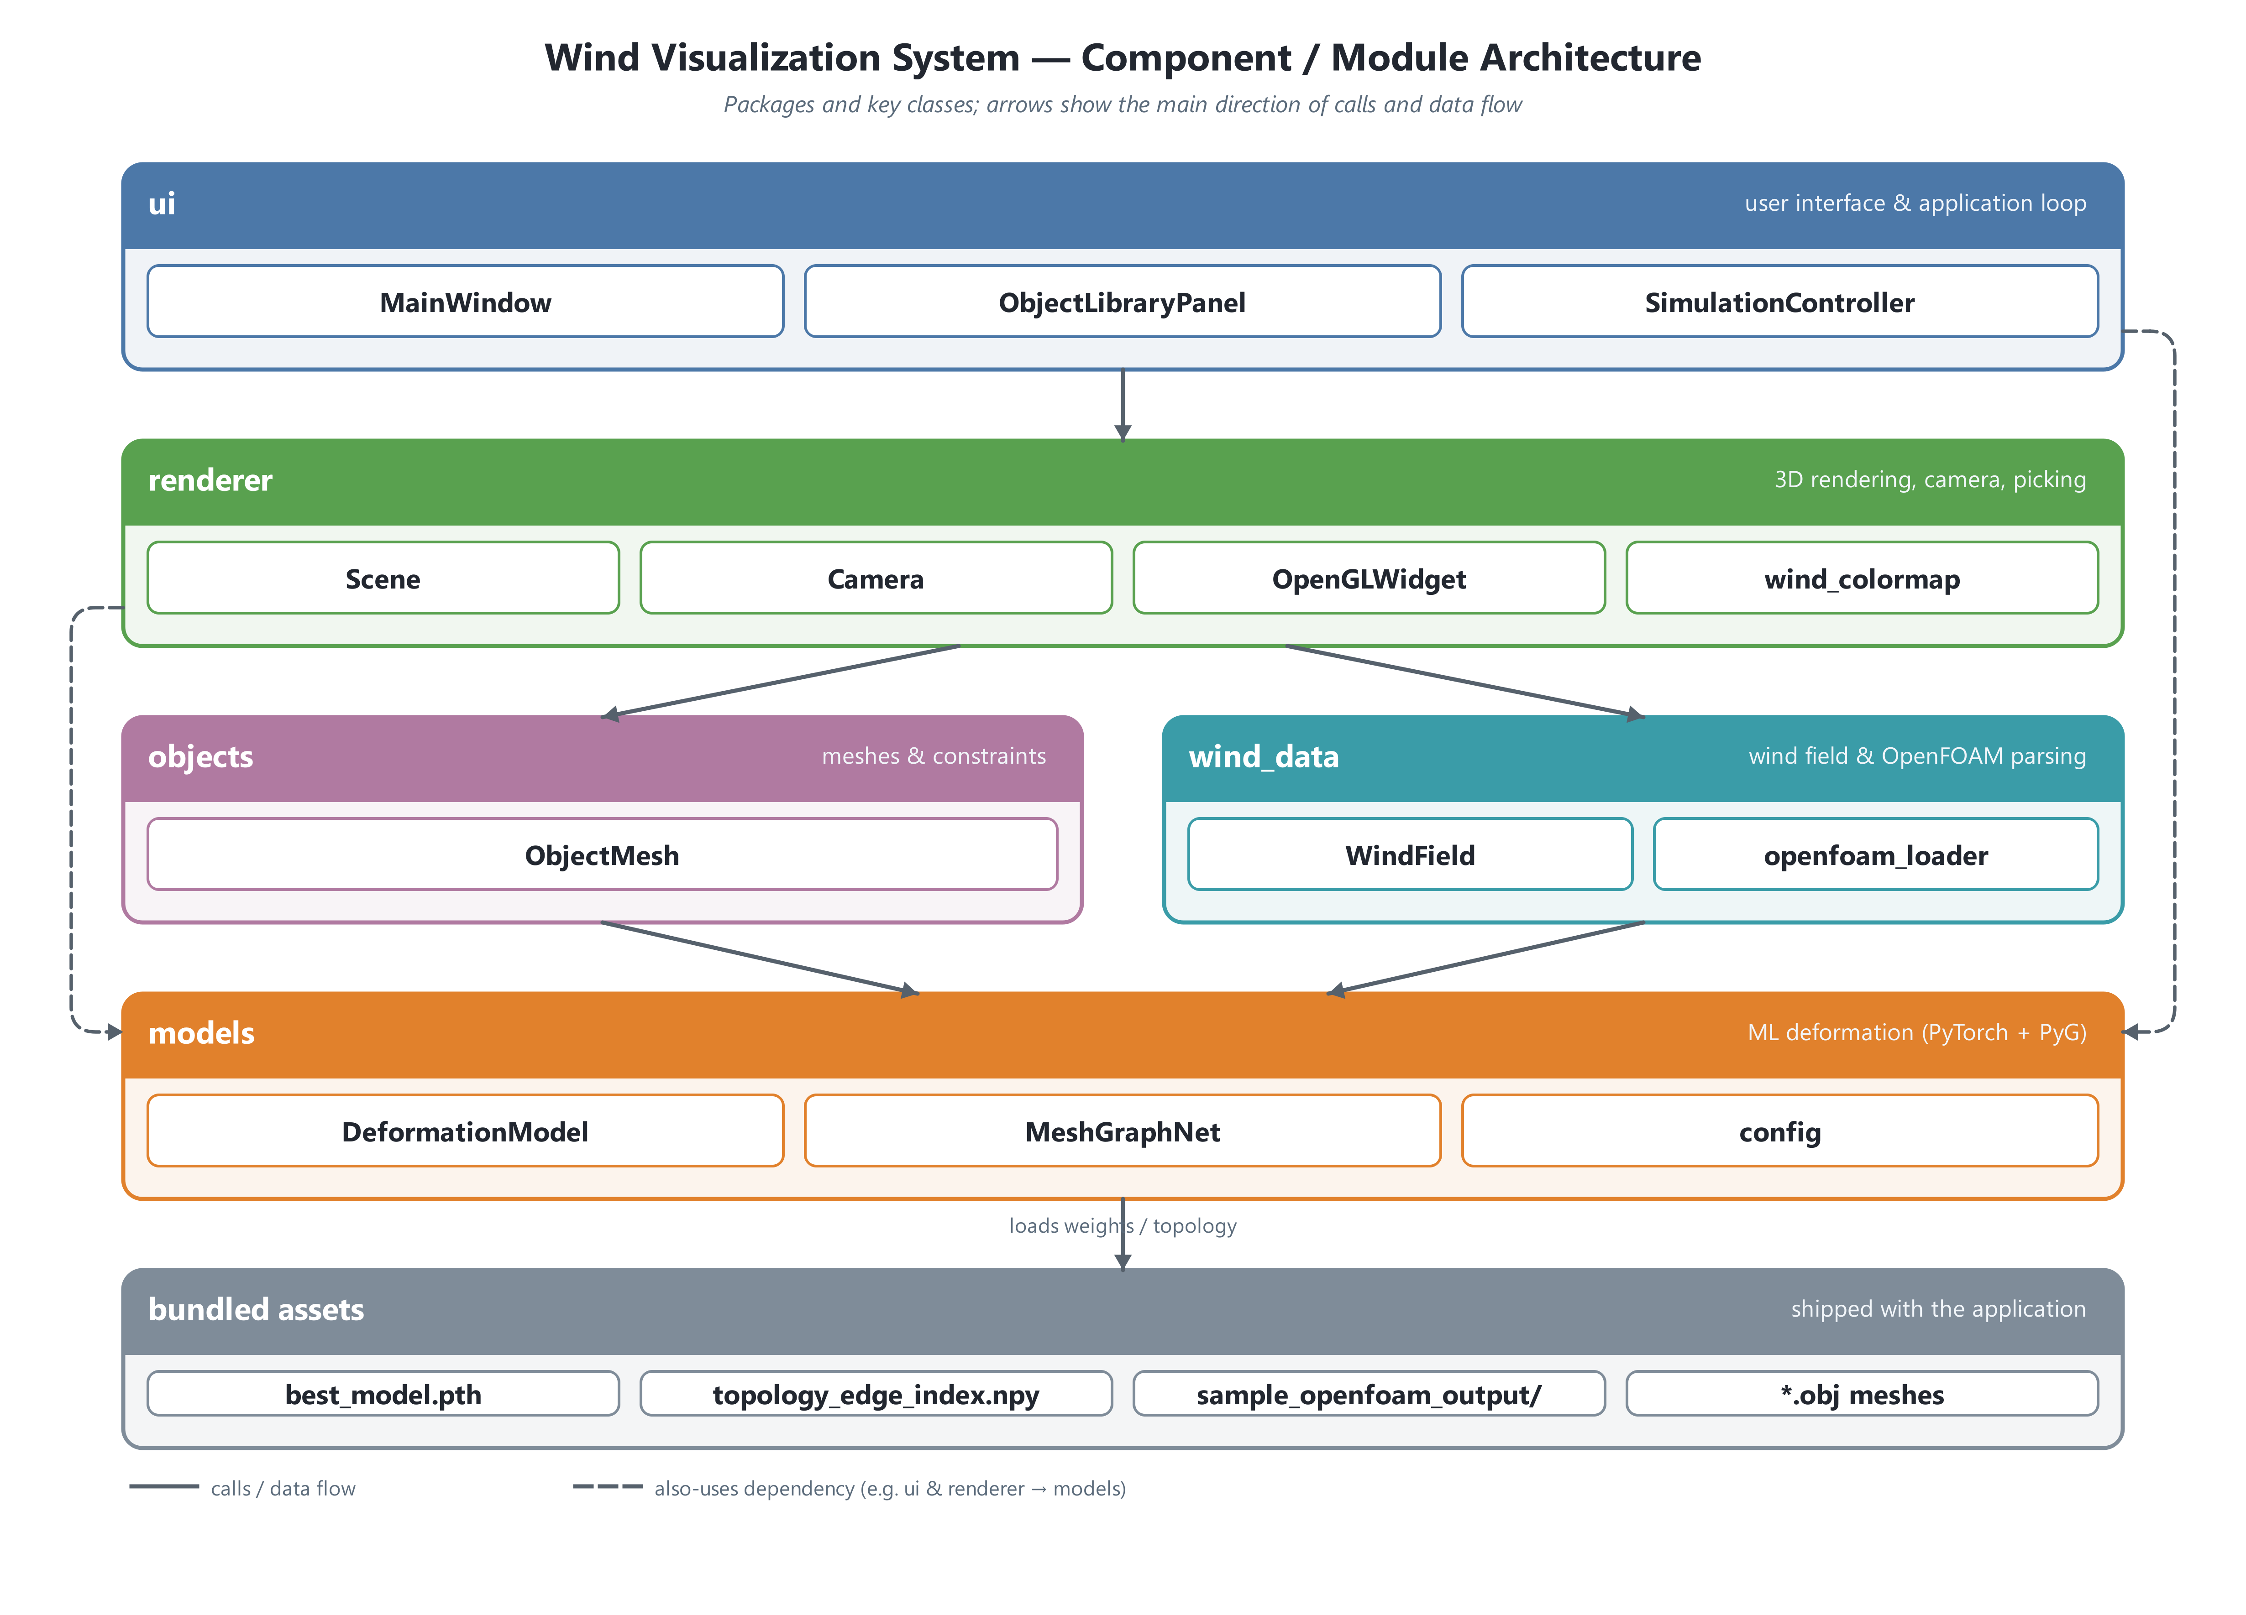
Figure 6-5: Component / module architecture of the Wind Visualization System
The 3D Scene, Wind Data and Visualisation. At the heart of the system is the WindField, which represents the wind as a five-dimensional NumPy array indexed by component, z, y, x and time; the three components are the velocity values (u_x, u_y, u_z) expressed in a right-handed, Z-up world frame whose ground plane lies at z = 0. The velocity at an arbitrary point is obtained by trilinear interpolation, so the field can be sampled smoothly at any object position rather than only at the grid nodes. When the application starts, the bundled OpenFOAM case in wind_data/sample_openfoam_output/ is parsed on a background thread (the _OpenFOAMCaseLoadWorker), which keeps the window responsive while the data loads. The loader reads the U_zNormal_*.raw velocity slices captured at three height levels and assembles them into the 5D array, filling any missing cells by a breadth-first nearest-neighbour search; it parses constant/polyMesh/boundary into the list of named flow patches; and it loads constant/triSurface/CAARC.stl as static building geometry that is drawn but never deformed. The ground grid then automatically resizes and centres itself to match the spatial bounds of the loaded wind field. The wind is drawn by the OpenGLWidget as a field of arrows, which the user can view either as a single resultant vector at each grid point or split into separate X, Y and Z components. A Beaufort wind-speed colour map, defined once in wind_colormap and mirrored by the legend in the control panel, tints each arrow according to its speed, while an adjustable downsampling stride and an automatically computed arrow scale keep the display legible across very different data sets. To keep interaction fluid, the arrow geometry is cached and rebuilt only when the underlying time step, stride, scale or data actually change, so that ordinary panning and zooming reuse the existing buffers.
[DIAGRAM 4 — Annotated UI Screenshot: place immediately after the "3D Scene, Wind Data and Visualisation" paragraph above. Show a screenshot of the running application's main window with callouts identifying the central OpenGL viewport, the left-hand Object Library dock, the right-hand Control Panel (display toggles, the resultant / component wind mode, the downsample stride, the Beaufort wind-speed legend and the statistics read-out), the top toolbar, and the bottom status bar reporting the cursor's world coordinates and the current frame rate.]
Object Placement and Interaction. A user builds a scene by dragging an object from the library onto the viewport, or by selecting an object and then clicking a location. In both cases the OpenGLWidget converts the screen position into a world position by casting a ray onto the ground plane (_screen_to_world) and snapping the result to the nearest grid cell (Scene.snap_to_grid); once the object is placed, the camera performs a brief animated dolly-in to frame it (start_focus_on_object). Holding Shift while dragging lifts an object vertically off the ground rather than moving it across the plane, which allows objects to be positioned at height within the wind field. The same viewport supports orbit, pan and zoom camera controls, a highlighted cell beneath the cursor, and a live read-out of the cursor's world coordinates in the status bar. Through the toolbar, the menus and the right-hand control panel the user can toggle the grid, the wind vectors and the static environment geometry, reset or clear the scene, and save or restore a complete scene as JSON. A set of keyboard shortcuts — Space to play or pause, R to reset, G and W to toggle the grid and the wind vectors, and C to reset the camera — mirrors the on-screen controls.
ML-Based Deformation and the Simulation Loop. Pressing Play starts the SimulationController, which advances the simulation on a fixed timer locked to the model's training rate of ten ticks per second (cfg.FPS, giving a constant time step of 0.1 s); the loop is deliberately not decoupled from this rate, because feeding the integrator a mismatched time step would destabilise the predicted motion. On every tick the controller advances the wind field by exactly one step and then, for each object, samples the wind velocity at the object's centre and passes the object's current and previous vertices to the DeformationModel. That model is a MeshGraphNet, consistent with the architecture described in Section 6.3.1: an encoder lifts the raw node and edge features into a 128-dimensional latent space, a stack of twelve message-passing processor blocks (using sum aggregation, with residual connections that let physical influence propagate across the mesh) iteratively updates that latent state, and a decoder projects it back into three-dimensional output. Each node carries the features velocity (3), wind (3) and a pinned flag (1), while each edge carries the relative position (3), its length (1), the relative velocity (3) and the rest length (1); from these the network predicts a per-vertex acceleration, which is integrated to obtain the next position. Because the decoder output is unbounded, the raw prediction is made physically safe before it is applied: the pinned nodes are re-fixed, the per-tick displacement of every free vertex is capped, and an XPBD-style strain projection clamps any over-stretched edge back to a small multiple of its rest length. Object-specific constraints are then enforced — the flag's pole edge, the cloth's corners and the tree's base are held fixed — after which the new vertices are committed, the surface normals are recomputed, and the viewport is repainted.
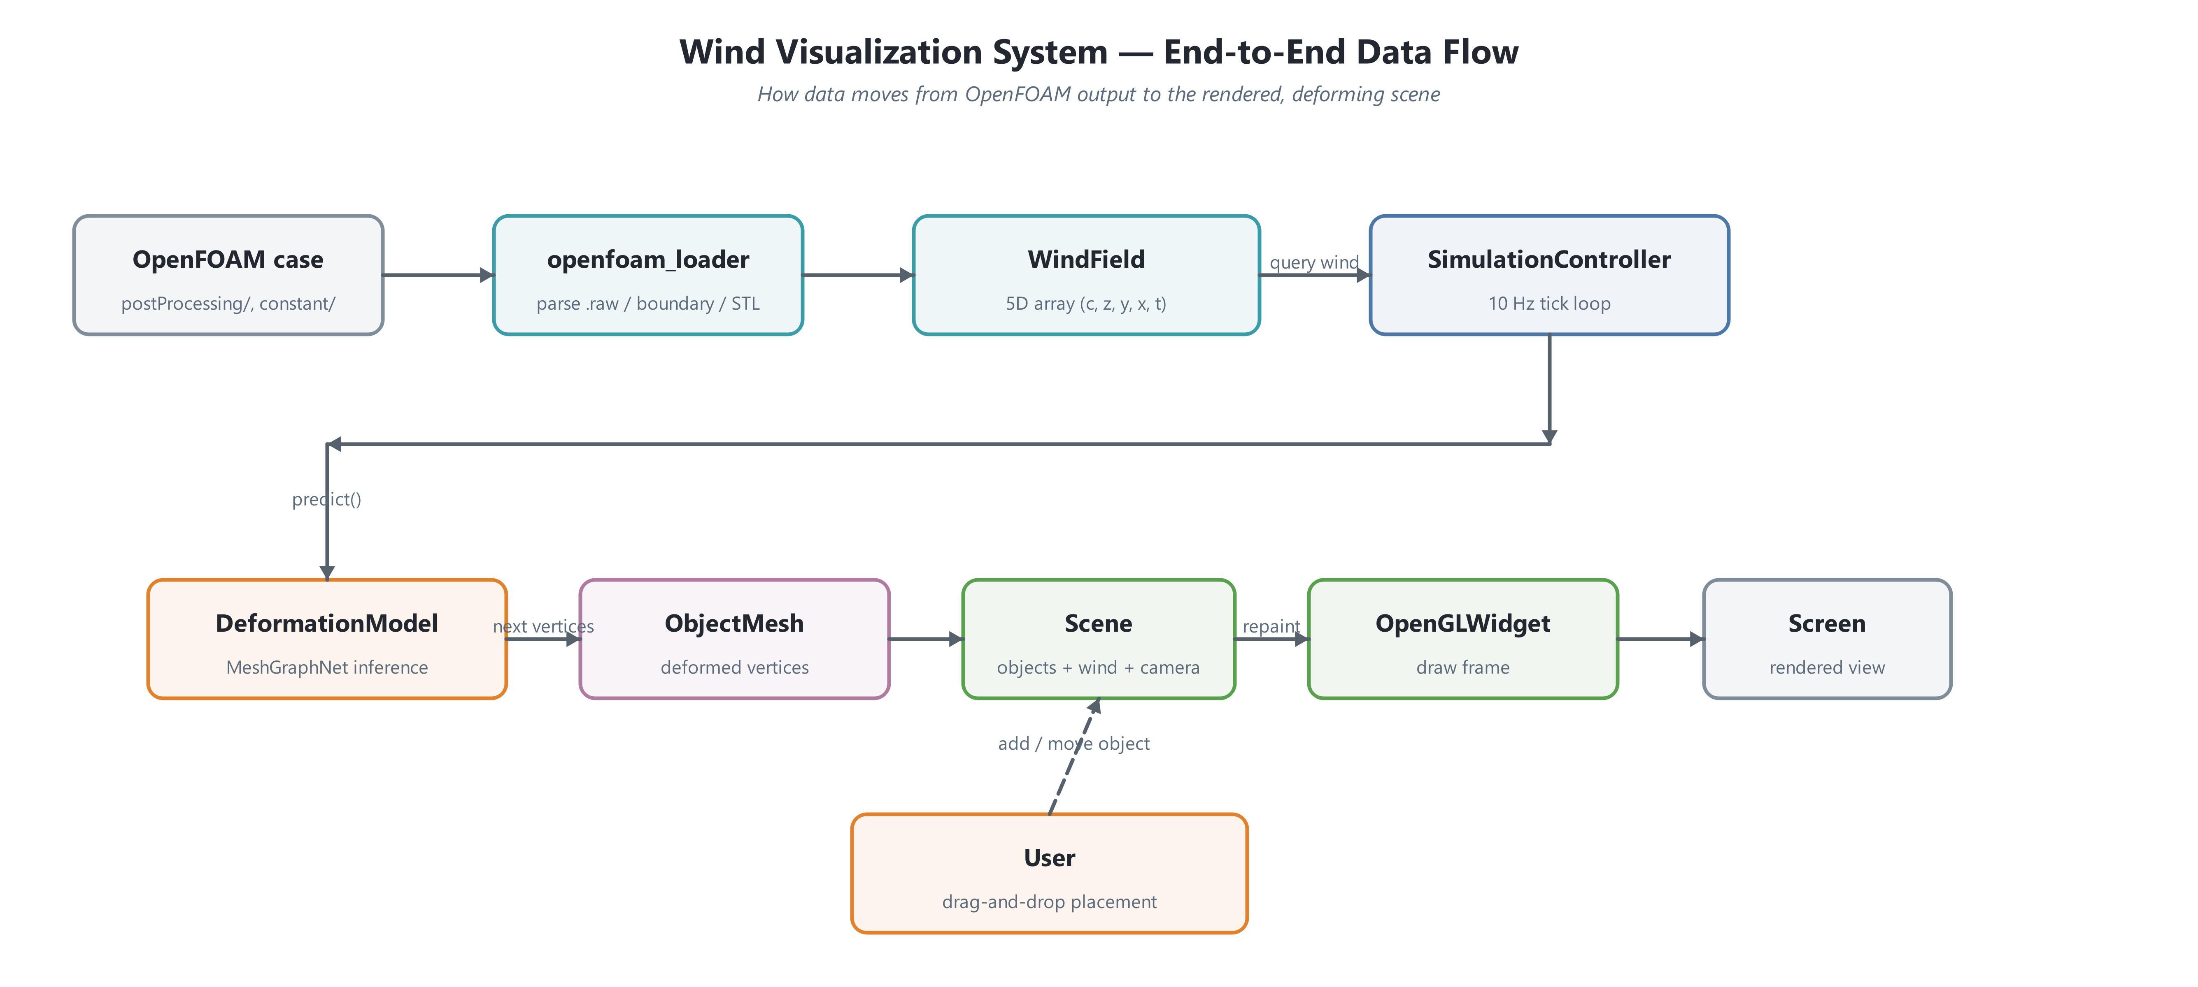
Figure 6-6: End-to-end data flow of the Wind Visualization System
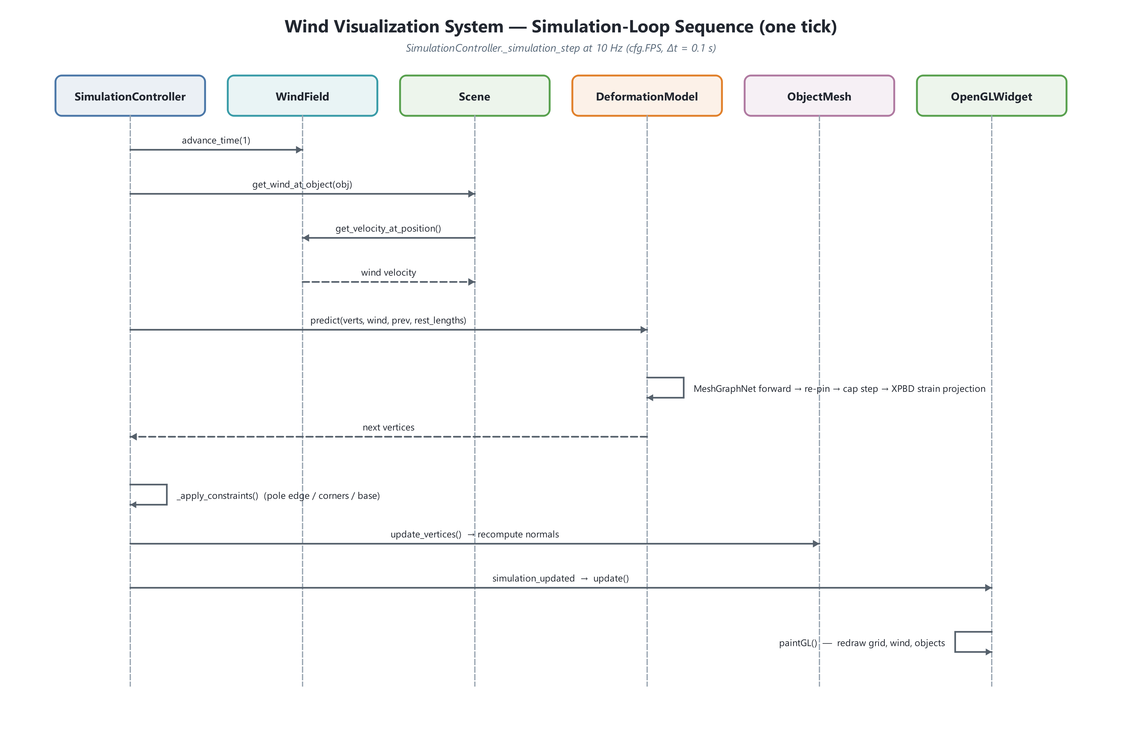
Figure 6-7: Simulation-loop sequence for one tick
Scope of the Deployed Model. It is important to be precise about what the bundled model actually deforms. The pretrained network was trained on the flag topology, and the bundled flag mesh (flag.obj) accordingly contains exactly 600 vertices, matching the model's expected mesh size of HEIGHT × WIDTH (20 × 30). When an object whose vertex count differs is encountered, DeformationModel.predict returns without producing a deformation, so the cloth (64 vertices), the pole (16 vertices) and the tree (25 vertices) can be placed, rendered, selected and constrained, but are not animated by the learned model in the current build. The flag therefore stands as the fully realised, end-to-end deformation case, while the placement, rendering, wind-sampling and constraint scaffolding built around it is general and ready to drive additional object types as further topologies are trained.
Technologies. The product is implemented entirely in Python. PyQt5 provides the windowing, docking and event system; PyOpenGL provides the real-time 3D rendering; NumPy underpins the wind field and all mesh mathematics; and PyTorch, together with PyTorch Geometric, executes the MeshGraphNet inference. The model runs on the GPU through CUDA when one is available and falls back to the CPU otherwise. Packaged with its portable Python runtime, the result is a self-contained application that turns dense CFD wind data into an interactive, physically plausible visualisation of how everyday objects respond to the wind.

Results
This section summarizes the experimental results of the proposed approach. It first presents the dataset validation results to confirm the quality and suitability of the data, followed by the model training results, which evaluate model performance using relevant metrics.

Dataset Validation Results
A basic grid search was employed to tune the MuJoCo simulation hyperparameters by quantitatively comparing its outputs against the ArcSim reference data. The validation was conducted across five different wind conditions ([0, 0, 0], [3, 3, 8], [5, 0, 5], [10, -2, 3], [-12, 0, 8]), with each setting consisting of 50 simulation frames. Using Chamfer Distance–based metrics for evaluation, the best-performing configuration achieved following values as shown in the table. These results indicate that the selected hyperparameter set provides a close geometric agreement between the MuJoCo and ArcSim simulations across the tested wind scenarios.

Chamfer Distance (m) | 0.235
Unidirectional Chamfer Distance (m) | 0.205

Following table shows the comparison between frames of ARCSim and MuJoCo for [30,30,30] wind value.
ARCSim | MuJoCo
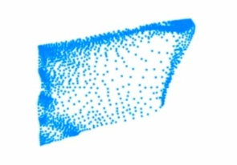  Frame 14 | 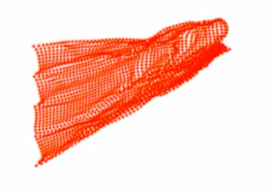  Frame 14
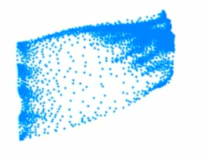  Frame 31 | 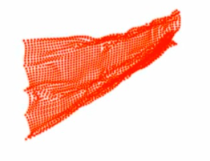  Frame 31
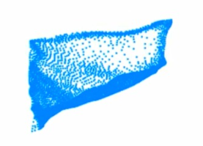  Frame 45 | 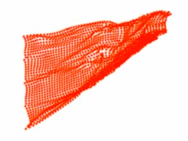  Frame 45

Model Training Results

This section presents the performance of the trained models, evaluated using multiple error metrics to capture both dynamic and geometric prediction accuracy. Three model architectures GNN, LSTM, and SNN were trained on the same dataset, and their final training loss, root mean squared error (RMSE) in acceleration, RMSE in distance, and edge error were recorded for comparison. These metrics provide a comprehensive view of each model’s ability to learn motion dynamics as well as spatial relationships within the simulated cloth system.

Model | Train Loss | RMSE  (acceleration) | RMSE  (distance) | Edge Error
GNN | 0.751 | 0.51 | 1.78 | 10.57
LSTM | 2.220 | 1.65 | 0.44 | 266.32
SNN | 4.921 | 2.60 | 0.71 | 70.10

As shown in the results, the GNN achieved the lowest training loss (0.751) and the lowest RMSE in acceleration (0.51), indicating strong performance in learning physically consistent dynamics. The LSTM model demonstrated the lowest RMSE in distance (0.44), suggesting better accuracy in predicting positional information, although it exhibited significantly higher edge error. In contrast, the SNN showed comparatively higher errors across most metrics, indicating reduced effectiveness for this task. Overall, the results highlight the trade-offs between temporal modeling and structural representation, with the GNN providing the most balanced performance across the evaluated metrics.
Following tables show the results of best trained model (GNN).

Ground Truth | Prediction
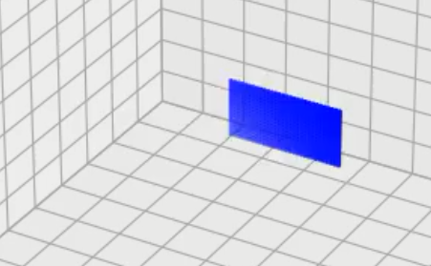  Frame 0 (t=0) | 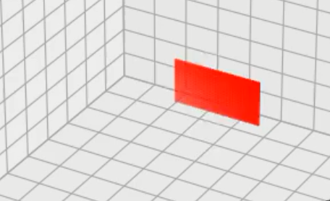  Frame 0 (t=0)
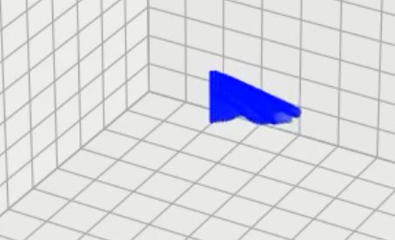  Frame 50 (t=5s) | 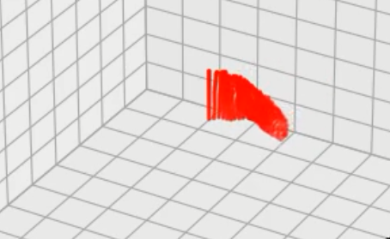  Frame 50 (t=5s)
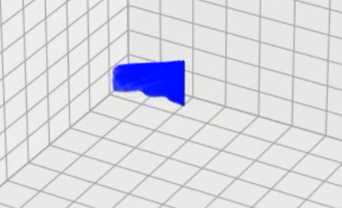  Frame 150 (t=15s) | 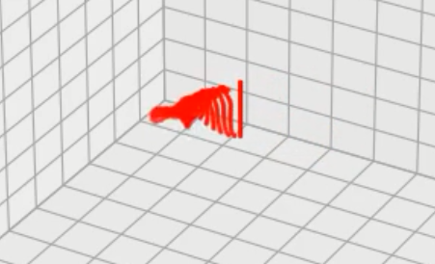  Frame 150 (t=15s)

Ground Truth | Prediction
  Frame 0 (t=0) |   Frame 0 (t=0)
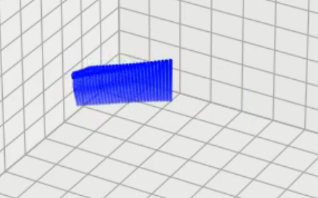  Frame 100 (t=10s) | 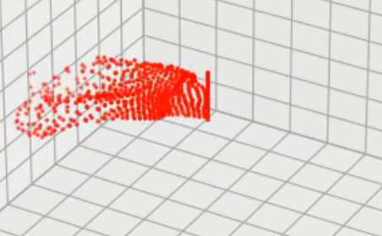  Frame 100 (t=10s)
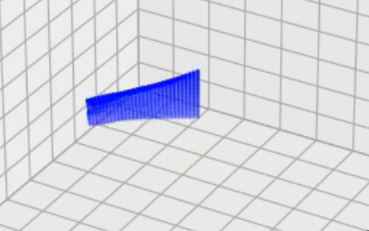  Frame 200 (t=20s) | 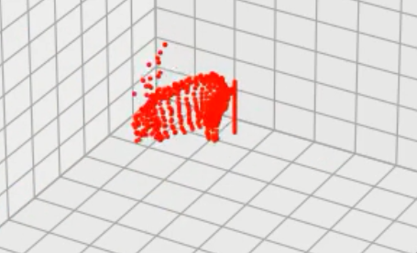  Frame 200 (t=20s)

Progress

Work | Progress
Literature Review | Completed
Wind Data Generation | Completed
Generating an Initial Training Dataset | Completed
Exploration of Baseline Model Architectures | Completed
Creating Basic Physical Losses | Completed
Dataset Validation and Improvement | In-Progress
Implementation of Hybrid Architectures | In-Progress
Physical Loss Improvement | To-Do
Building the Final Software | In-Progress
Final Testing | To-Do

Conclusion
The WindVerse project aims to bridge the gap between complex wind simulation data and its understanding by non-expert stakeholders. At this stage, the project has focused on building and validating the computational foundation required to visually represent wind effects in an intuitive and meaningful way.
Progress has been made in generating and validating physics-based simulation data using deformable objects such as flags. A comparison between high-fidelity simulations was carried out to ensure data consistency across multiple wind conditions. This validated dataset was then used to train machine learning models capable of approximating physical behavior efficiently.
Initial training and evaluation of multiple model architectures demonstrate that the system can achieve a balance between accuracy and computational performance. These results confirm the feasibility of real-time wind visualization, providing a strong basis for the next phase, which will focus on interactive system integration and user-facing visualization.

Bibliography
- E. Ng, “Policies and technical guidelines for urban planning of high-density cities – air ventilation assessment (AVA) of Hong Kong,” Building and Environment, vol. 44, no. 7, pp. 1478–1488, Aug. 2008, doi: 10.1016/j.buildenv.2008.06.013.

- X. Liu et al., “Wind environment assessment and planning of urban natural ventilation corridors using GIS: Shenzhen as a case study,” Urban Climate, vol. 42, p. 101091, Jan. 2022, doi: 10.1016/j.uclim.2022.101091.

- T.-O. Hågbo and K. E. T. Giljarhus, “Pedestrian wind comfort assessment using computational fluid dynamics simulations with varying number of wind directions,” Frontiers in Built Environment, vol. 8, Jul. 2022, doi: 10.3389/fbuil.2022.858067.

- H. Mittal, A. Sharma, and A. Gairola, “A review on the study of urban wind at the pedestrian level around buildings,” Journal of Building Engineering, vol. 18, pp. 154–163, Mar. 2018, doi: 10.1016/j.jobe.2018.03.006.

- V. J. L. Gan, T. Liu, and K. Li, “Integrated BIM and VR for interactive aerodynamic design and wind comfort analysis of modular buildings,” Buildings, vol. 12, no. 3, p. 333, Mar. 2022, doi: 10.3390/buildings12030333.

- R. Mitkov, M. Pantusheva, D. Petrova-Antonova, V. Naserentin, and A. Logg, “The Role of Computational Fluid Dynamics within City Digital Twins: Opportunities and Challenges,” ISPRS Annals of the Photogrammetry, Remote Sensing and Spatial Information Sciences, vol. X-4/W4-2024, pp. 131–136, May 2024, doi: 10.5194/isprs-annals-x-4-w4-2024-131-2024.

- “Beaufort Wind Scale.” https://www.hko.gov.hk/en/education/weather/meteorology-basics/00112-beaufort-wind-scale.html

- X.-J. Cheng, H.-F. Zhang, and R. Xie, “Study on 3D Laser Scanning Modelling Method for Large-Scale History Building,” 2010 International Conference on Computer Application and System Modelling (ICCASM 2010), pp. V7-577, Oct. 2010, doi: 10.1109/iccasm.2010.5620631.

- Ruchay, Dorofeev, and Kolpakov, “Fusion of information from multiple Kinect sensors for 3D object reconstruction,” Computer Optics, vol. 42, no. 5, pp. 898–903, 2018, doi: 10.18287/2412-6179-2018-42-5-898-903.

- I. Kavrakov, A. McRobie, and G. Morgenthal, “Data-driven aerodynamic analysis of structures using Gaussian Processes,” Journal of Wind Engineering and Industrial Aerodynamics, vol. 222, p. 104911, Feb. 2022, doi: 10.1016/j.jweia.2022.104911.

- Y. Wang, Y. Xiong, K. Xu, K. Tan, and G. Guo, “A mass-spring model for surface mesh deformation based on shape matching,” Proceedings of the 4th International Conference on Computer Graphics and Interactive Techniques in Australasia and Southeast Asia 2006, pp. 375–380, Nov. 2006, doi: 10.1145/1174429.1174493.

- Ouoba, Saria, Sourabié, Barandja, Zoungrana, and Zerbo, “Modelling the impact of different wavelengths of sunlight on the performance of a silicon photovoltaic (PV) cell,” International Journal of Physical Sciences, vol. 20(2), pp. 69–80, 2025, [Online]. Available: https://academicjournals.org/journal/IJPS/article-abstract/417CDA273537

- L. Zaidi, B.-C. Bouzgarrou, L. Sabourin, and Y. Mezouar, “Interaction modelling in the grasping and manipulation of 3D deformable objects,” 2015 International Conference on Advanced Robotics (ICAR), pp. 504–509, Jul. 2015, doi: 10.1109/icar.2015.7251503.

- V. Mozafary and P. Payvandy, “Study and comparison techniques in fabric simulation using mass spring model,” International Journal of Clothing Science and Technology, vol. 28, no. 5, pp. 634–689, Aug. 2016, doi: 10.1108/ijcst-03-2015-0033.

- Y. Li, H. Xu, and J. Barbic, “Enriching Triangle Mesh Animations with Physically Based Simulation,” IEEE Transactions on Visualization and Computer Graphics, vol. 23, no. 10, pp. 2301–2313, Oct. 2016, doi: 10.1109/tvcg.2016.2620467.

- Petit, V. Lippiello, and B. Siciliano, “Real-time tracking of 3D elastic objects with an RGB-D sensor,” 2021 IEEE/RSJ International Conference on Intelligent Robots and Systems (IROS), pp. 3914–3921, Sep. 2015, doi: 10.1109/iros.2015.7353928.

- Petit, F. Ficuciello, G. A. Fontanelli, L. Villani, and B. Siciliano, “Using physical modelling and RGB-D registration for contact force sensing on deformable objects,” Proceedings of the 15th International Conference on Informatics in Control, Automation and Robotics, pp. 24–33, Jan. 2017, doi: 10.5220/0006415900240033.

- Bosse and Beck, “Simplified finite elements model to represent mass-spring structures in dynamic simulation,” Rio De Janeiro, RJ: ABCM, 2018.

- U. Meier, O. López, C. Monserrat, M. C. Juan, and M. Alcañiz, “Real-time deformable models for surgery simulation: a survey,” Computer Methods and Programs in Biomedicine, vol. 77, no. 3, pp. 183–197, Jan. 2005, doi: 10.1016/j.cmpb.2004.11.002.

- M. Desbrun and M.-P. Gascuel, “Animating soft substances with implicit surfaces,” Proceedings of the 22nd Annual Conference on Computer Graphics and Interactive Techniques, pp. 287–290, Jan. 1995, doi: 10.1145/218380.218456.

- F. Liu, X. Zhou, B. Dai, R. Yan, Z. Yin, and J. Yin, “Large deformation analysis in geotechnics using the node-based smoothed RPIM and second order cone programming,” Computers and Geotechnics, vol. 187, p. 107514, Jul. 2025, doi: 10.1016/j.compgeo.2025.107514.

- M. R. Yousefi, R. Jafari, and H. A. Moghaddam, “A combined Wavelet-Based Mesh-Free method for solving the forward problem in electrical impedance tomography,” IEEE Transactions on Instrumentation and Measurement, vol. 62, no. 10, pp. 2629–2638, Jun. 2013, doi: 10.1109/tim.2013.2259113.
- Ling, L., Damodaran, M., & Gay, R. K. (1996). A model for animating the motion of cloth. Computers & Graphics, 20(1), 137–156. https://doi.org/10.1016/0097-8493(95)00073-9

- Müller and Gross, “Interactive Virtual Materials,” Proceedings of Graphics Interface (GI), pp. 239–246, 2004, doi: 10.5555/1006058.

- Tang, M., Wang, H., Tang, L., Tong, R., & Manocha, D. (2016). CAMA: Contact‐Aware Matrix Assembly with Unified Collision Handling for GPU‐based Cloth Simulation. Computer Graphics Forum, 35(2), 511–521. https://doi.org/10.1111/cgf.12851

- R. Narain, A. Samii, and J. F. O’Brien, “Adaptive anisotropic remeshing for cloth simulation,” ACM Transactions on Graphics, vol. 31, no. 6, pp. 1–10, Nov. 2012, doi: 10.1145/2366145.2366171.

- A. Sanchez-Gonzalez, J. Godwin, T. Pfaff, R. Ying, J. Leskovec, and P. Battaglia, “Learning to Simulate Complex Physics with Graph Networks,” PMLR, Nov. 21, 2020. https://proceedings.mlr.press/v119/sanchez-gonzalez20a.html

- L. Vazquez-Aguilar and V. E. Arriola-Rios, “Prediction of deformations on elastic objects using an LSTM model,” in Lecture notes in computer science, 2024, pp. 59–72. doi: 10.1007/978-3-031-71360-6_5.

- Tawbe, “A learning-based method for 3D object modelling and deformation prediction using neural networks - Dépôt institutionnel de l’UQO,” Ph.D. dissertation, Université du Québec en Outaouais (UQO), 2021. [Online]. Available: https://di.uqo.ca/id/eprint/1341/1/Tawbe_Bilal_2021_these.pdf

- M. Saleh, M. Sommersperger, N. Navab and F. Tombari, "Physics-Encoded Graph Neural Networks for Deformation Prediction under Contact," 2024 IEEE International Conference on Robotics and Automation (ICRA), Yokohama, Japan, 2024, pp. 17160-17166, doi: 10.1109/ICRA57147.2024.10610366.

- M. Raissi, P. Perdikaris, and G. E. Karniadakis, “Physics-informed neural networks: A deep learning framework for solving forward and inverse problems involving nonlinear partial differential equations,” Journal of Computational Physics, vol. 378, pp. 686–707, Nov. 2018, doi: 10.1016/j.jcp.2018.10.045.

- G. E. Karniadakis, I. G. Kevrekidis, L. Lu, P. Perdikaris, S. Wang, and L. Yang, “Physics-informed machine learning,” Nature Reviews Physics, vol. 3, no. 6, pp. 422–440, May 2021, doi: 10.1038/s42254-021-00314-5.

- S. Wang, S. Sankaran, and P. Perdikaris, “Respecting causality is all you need for training physics-informed neural networks,” arXiv (Cornell University), Jan. 2022, doi: 10.48550/arxiv.2203.07404.

- A. Aygun, R. Maulik, and A. Karakus, “Physics-informed neural networks for mesh deformation with exact boundary enforcement,” Engineering Applications of Artificial Intelligence, vol. 125, p. 106660, Jul. 2023, doi: 10.1016/j.engappai.2023.106660.

- Sheshadri and Park, “Mesh deformation algorithms for fluid–structure interaction studies,” AIAA Scitech 2020 Forum, Jan. 2020, [Online]. Available: https://www.researchgate.net/publication/344320625

- Foley, Van Dam, Feiner, and Hughes, “Displacement mapping for efficient surface detail representation,” Proc. SIGGRAPH, 1985, [Online]. Available: https://citeseerx.ist.psu.edu/document?doi=9afa9457bca78a3355517fc444f085b9bfaf6a67

- L. Szirmay‐Kalos and T. Umenhoffer, “Displacement mapping on the GPU — state of the art,” Computer Graphics Forum, vol. 27, no. 6, pp. 1567–1592, Sep. 2008, doi: 10.1111/j.1467-8659.2007.01108.x.

- J. R. Crawshaw, J. A. Flegg, and J. M. Osborne, “A simple history dependent remeshing technique to increase finite element model stability in elastic surface deformations,” arXiv (Cornell University), Jan. 2020, doi: 10.48550/arxiv.2011.06756.

- T. F. H. Runia, K. Gavrilyuk, C. G. M. Snoek, and A. W. M. Smeulders, “Cloth in the Wind: A case study of physical measurement through Simulation,” 2020. https://openaccess.thecvf.com/content_CVPR_2020/html/Runia_Cloth_in_the_Wind_A_Case_Study_of_Physical_Measurement_CVPR_2020_paper.html
- D. Blanco-Mulero, O. Barbany, G. Alcan, A. Colomé, C. Torras and V. Kyrki, "Benchmarking the Sim-to-Real Gap in Cloth Manipulation," in IEEE Robotics and Automation Letters, vol. 9, no. 3, pp. 2981-2988, March 2024, doi: 10.1109/LRA.2024.3360814

